**Supplementary Material**

**Virologica Sinica**

**A quadrivalent norovirus vaccine based on a chimpanzee adenovirus vector induces potent immunity in mice**

Yihua Jiang a,1, Lingjin Sun a, 1,Nan Qiao a, 1, Xiang Wang b,Caihong Zhu b, Man Xing a, b, Hui Liu c, * ,

Ping Zhou a, d, *, Dongming Zhou a, b, *

aDepartment of Pathogen Biology, School of Basic Medical Sciences, Tianjin Medical University, Tianjin, 300070, China.

b Shanghai Public Health Clinical Center, Fudan University, Shanghai, 201508, China.

c R&D Centre, Chengdu Kanghua Biological Products Co., Ltd, , Chengdu, 610000, China.

d Institut Pasteur of Shanghai, Chinese Academy of Sciences, Shanghai, 200031, China.

*Corresponding authors.

Email address: zhoudongming@tmu.edu.cn (D. Zhou), 17317825924@163.com (P. Zhou), liuhui@kangh.com (H. Liu)

ORCID: 0000-0002-5989-7591 (D. Zhou)

1 Yihua Jiang, Lingjin Sun, and Nan Qiao contributed equally to this work.

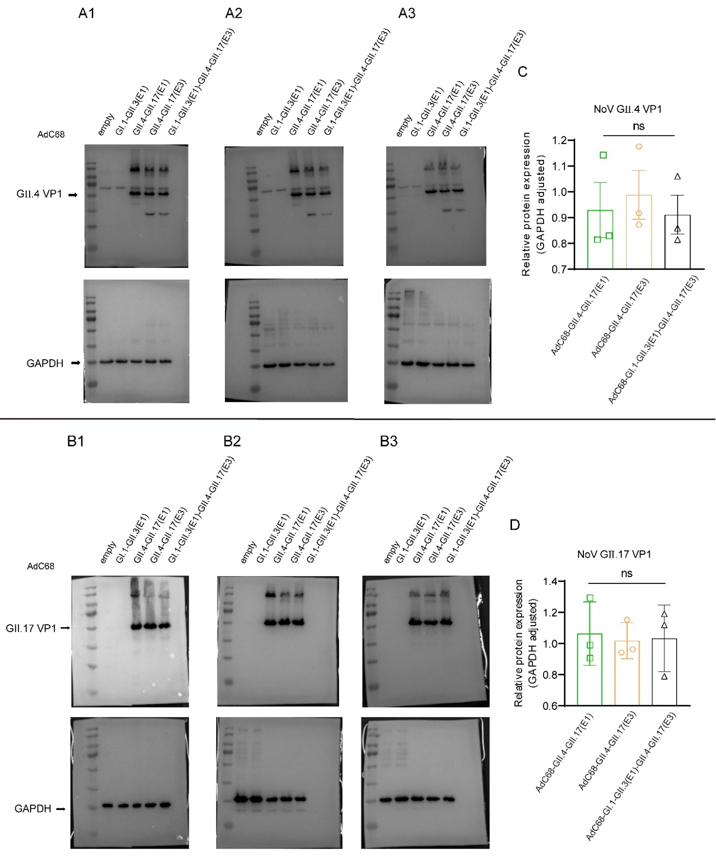

**Fig. S1** Expression of GⅡ.4 and GII.17 VP1 protein analyzed by Western blot. The HEK 293 cells were infected with the indicated adenoviruses at 5 × 106 infectious unites (IFU). AdC68-empty-transduced (5 × 106 IFU) HEK293 cells were used as controls. After 24 h, the cells were collected to check the expression of VP1 using mouse monoclonal antibody against NoV-GⅡ.4-VP1 (**A1-A3**) or NoV-GⅡ.17-VP1 (**B1-B3**) with three repeated assays. GAPDH was used as the internal control correspondingly. The relative expression of VP1 was compared with the corresponding GAPDH (**C, D**). Data was shown as mean ± SEM and analyzed using a one-way analysis of variance with Tukey's multiple comparison test (*ns, P > 0.05*). Expression of VP1 of GII.4 analyzed by Western blot.

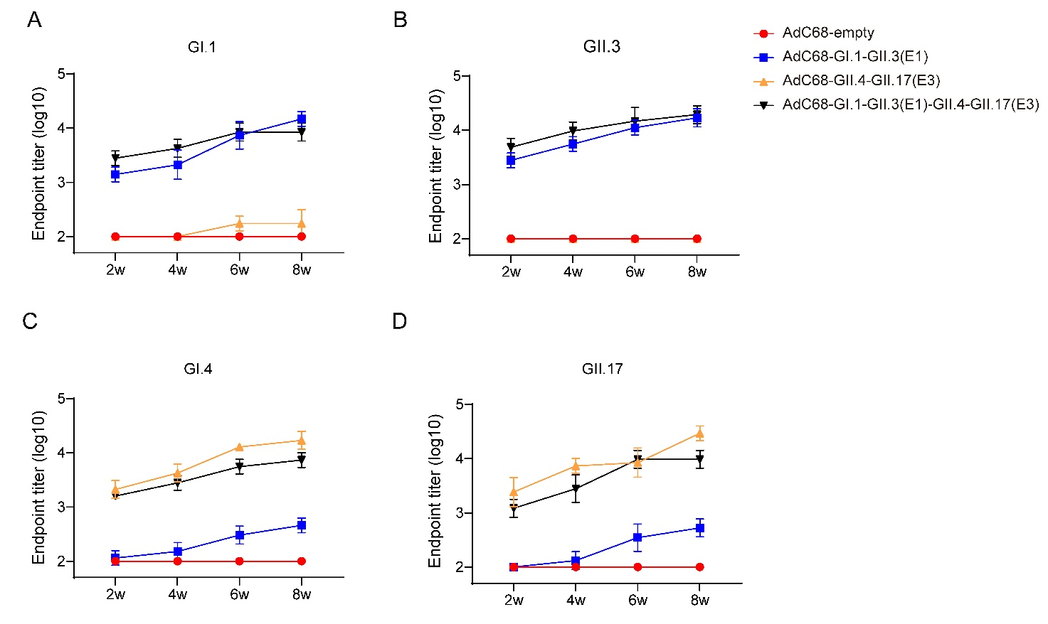

**Fig. S2**Dynamic changes of IgG antibody levels after i.m. in mice. A-D. Mice were immunized i.m. with the bivalent vaccine AdC68-GI.1-GII.3 (E1) or AdC68-GII.4-GII.17 (E3), or the quadrivalent vaccine AdC68-GI.1-GII.3 (E1)-GII.4-GII.17 (E3) at a dose of 1 × 108 IFU (n=5). At two, four, six, and eight weeks, titers of IgG in serum against VLP-GI.1 (**A**), VLP-GII.3 (**B**), VLP-GII.4 (**C**), and VLP-GII.17 (**D**) were determined by ELISA. AdC68-empty was used as a control.